Teacher’s Resource Booklet

Interview With a Fictional Character

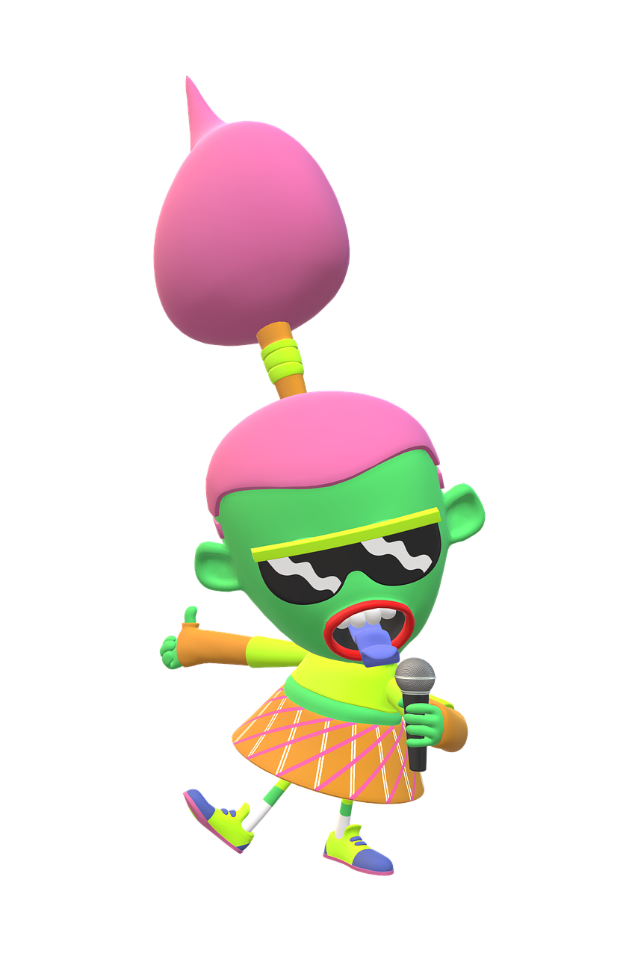

This booklet contains :

Activity 1 – Podcasting Terms
Activity 1 – Listening Grid
Activity 3 – Grammar Review
Question Game

Activity 7 – Feedback Grid

Podcasting Terms
What is the difference between a podcast and podcasting?
Podcast
"A podcast is an audio or video file that can be downloaded by Internet users. The file can include a video conference, report, radio broadcast, etc." Source: IG Global
Enhanced Podcast
“An Enhanced podcast also known as a slidecast is a type of podcast that combines audio with a slide show presentation. It is similar to a video podcast in that it combines dynamically-generated imagery with audio synchronization, but it is different in that it uses presentation software, such as PowerPoint, to create the imagery and the sequence of display separately from the time of the original audio podcast recording.” Source: Wikipedia
Podcasting
"Podcasting is a method of sharing audio or video files over the Internet so that they can be downloaded and played on a portable media player or computer with Internet access." Source: IG Global

Activity 1 – The Second Interview
Listen to the second interview. Complete the following grid.
Name of the podcast episode:  Topic: | Host:  Guest:
Text | Audio
Intention  Check one or more boxes  Does the interview… ?  inform:  - a news broadcast  - a current affairs program  - a documentary  - a debate  - a talk show  entertain:  - a music show  - a variety show  - a talent show  promote:  - a public affairs message  - a program announcement  - a simulated commercial or an infomercial  How long is the interview?  How many questions are asked? | What is the tone of voice? (intimate, personal, familiar, neutral,distant)?  Rate the quality of these aspects of the podcast.  The rhythm is well-adjusted to the content.  - Totally agree  - Agree  - Somewhat agree  - Disagree  - Totally disagree  Voice and music are well-balanced.  - Totally agree  - Agree  - Somewhat agree  - Disagree  Music components  If there is music, what type of music is it ?  Is there music at the beginning of the show? Yes No  Is there background music throughout the show? Yes No  Is there a final musical theme? Yes No

Additional Information - Optional

Technical Elements
What you need to produce your interview

Equipment

A computer with an audio software like Audacity
A unidirectional mike (mic) and headphones or headsets and splitters
A table and some chairs
Question sheets for the interviewer

Human Resources

An interviewer (host)
A guest
A producer to direct the production and edit the sound track
Researchers – all team members should be involved in the research process

Technical Aspects
The ideal environment
Create an appropriate environment

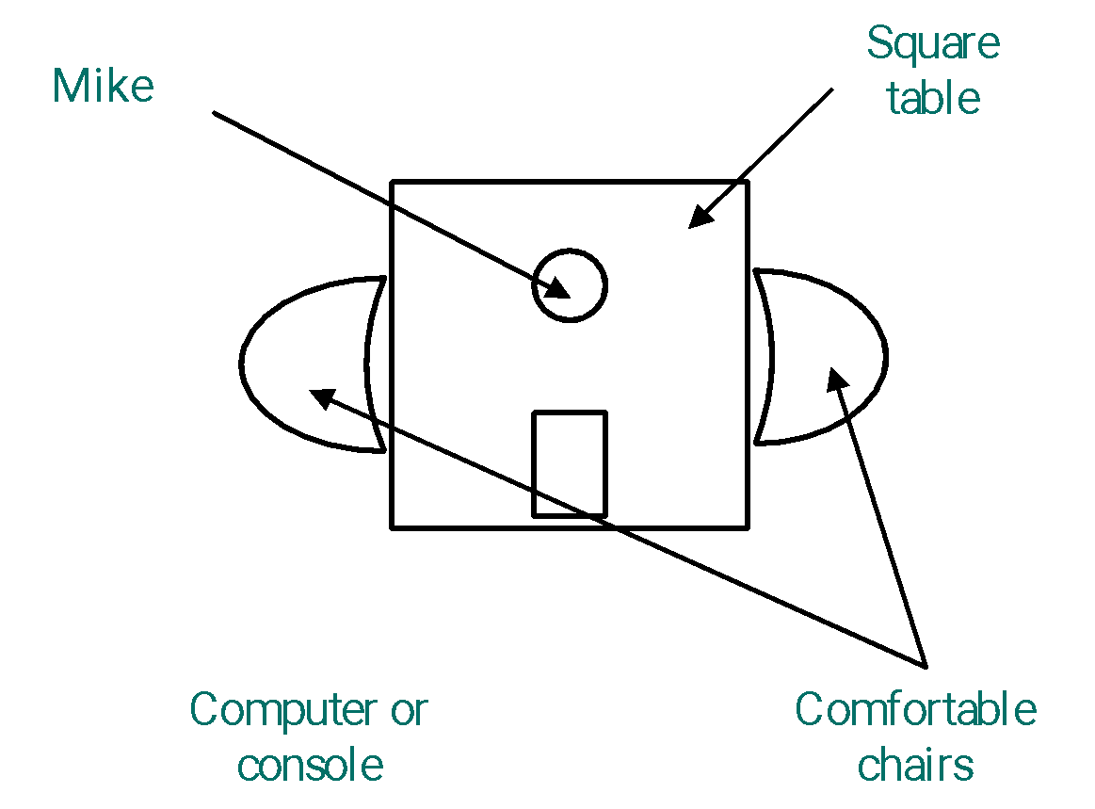
The quality of an interview lies in the ability
to create an impression of closeness
between the interviewer and the guest.
This depends to a great extent on
the personality of the interviewer.

It is certainly possible to physically
Computer with headsets if you are not using the microphone
contribute to this impression of intimacy
by placing the furniture in such a way
as to facilitate a certain degree of
closeness between the host and
his/her guest. This is illustrated in the
floor plan at the right.

Also, when choosing a musical introductory theme (signature) for the show, it is important to choose a music theme (tone, rhythm, length) that suits your type of interview and your target listening audience.

WE’RE TAKING THE BUS.

HOW OLD ARE YOU?

I AM 12 YEARS OLD.

SHE’S MY COUSIN.

WHO IS YOUR TEACHER?

HOW MUCH IS THAT PAIR OF IN-LINE SKATES?

I WILL GO TO
NOTRE-DAME DES PINS SCHOOL.

IT’S 450-867-5309.

I LIVE IN ST-LAMBERT.

ACTIVITY 3
WH + HOW QUESTIONS
GRAMMAR REVIEW GAME

WHICH SECONDARY SCHOOL ARE YOU GOING TO NEXT YEAR?

WHO IS THAT GIRL?

Print. Cut questions and answers separately. Keep answers; hand out a question to each student.

WHAT’S YOUR PHONE NUMBER?

HOW ARE YOU GOING TO
OTTAWA?

MY TEACHER IS MR. HART.

WHERE DO YOU LIVE?

THEY’RE EXPENSIVE, ABOUT $300.

WHEN IS YOUR BIRTHDAY?

MY BIRTHDAY IS NOVEMBER 28.

HOW LONG IS YOUR ENGLISH CLASS?

IT IS ONE HOUR LONG.

WHICH ONE DO YOU WANT: THE RED ONE OR THE BLUE ONE?

I’LL HAVE THE BLUE ONE, PLEASE.

WHAT IS IN YOUR POCKET?

I HAVE SOME MONEY AND GUM.

WHERE IS YOUR HOMEWORK?

IT’S AT HOME.

WHAT IS YOUR FAVOURITE DESSERT?

I LOVE CHOCOLATE BROWNIES.

HOW MANY FINGERS DO YOU HAVE?

I HAVE 10 FINGERS.

HOW MANY SIBLINGS DO YOU HAVE?

I HAVE 4 SISTERS AND 2 BROTHERS.

WHAT TIME IS IT?

IT IS TIME TO GO HOME.

