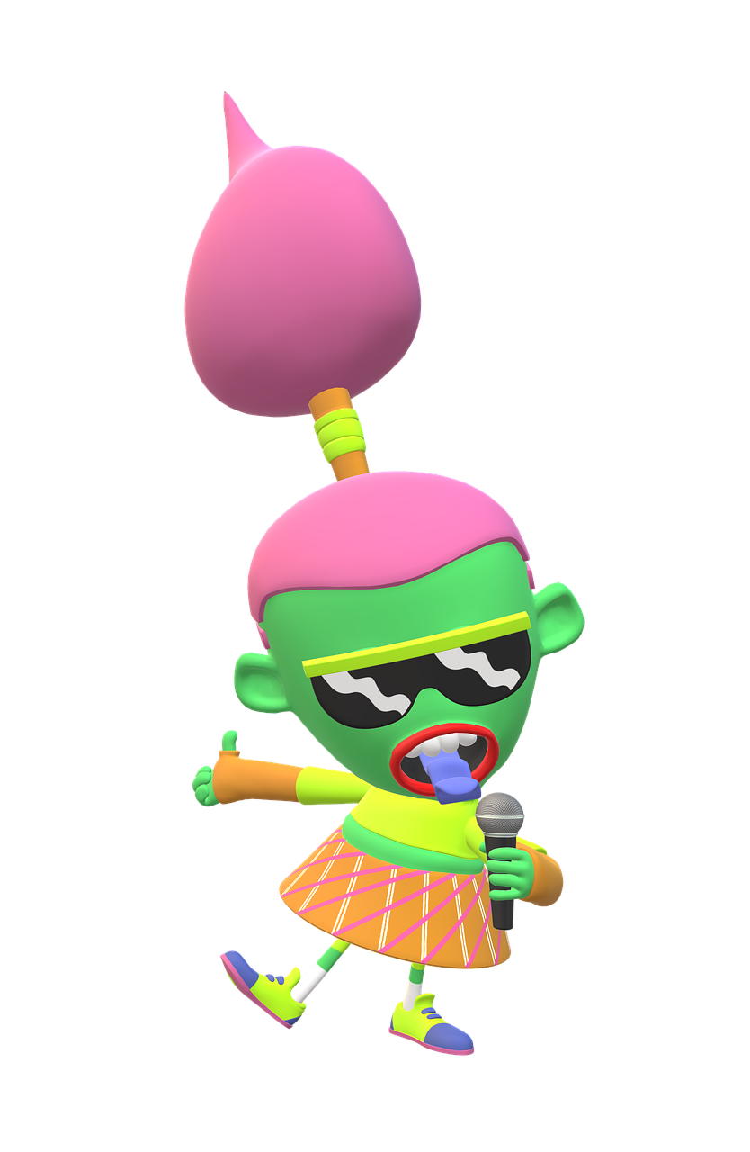
Learning and Evaluation Situation

Interview With a Fictional Character
Elementary Cycle 3

Sandra Laine, Service national du RÉCIT, domaine des langues
Solange Moseley, Pedagogical Counselor
Educational Intention
The goal of this learning and evaluation situation is to guide and support students in creating their own podcasts.
* See page 3 of the Teacher’s Guide for an overview of the tasks and activities.
Context:
Students prepare an interview with a fictional character. This is the first step to equip students with the necessary skills to subsequently prepare podcast interviews.

Teaching cycle | Design Team
Cycle 3 Elementary | Sandra Laine, Service National du RÉCIT, Domaine des langues (2009)  Solange Moseley, Pedagogical Counselor (2009)  Updated Version 2023  Service national du RÉCIT, domaine des langues
Digital Competency Dimensions

- Developing and mobilizing technology technology skills
- Developing and mobilizing information literacy
- Producing content via digital technology

LES – Interview with a Fictional Character - Overview

Step 1 |  |  | Step 2 |  |  | Step 3
Activity 1 | Activity 2 | Activity 3 | Activity 4 | Activity 5 | Activity 6 | Activity 7
Warm-up  What is a Podcast?  Listening to two interviews  Completing the listening grid | Getting Ready  Presenting the activity  What is an interview?  Choosing the fictional character | Grammar Review  (Optional)  Wh questions  Jeopardy Game | Researching and preparing the interview | Storyboarding | Practising and recording the interview | Feedback  Self-evaluation
 | C1 |  | C1 | C1 |  | C1
60 minutes | 60 minutes | 15-30 minutes | 120 minutes | 30 minutes | 60-120 minutes | 30- 60 minutes

Content Overview
ESL Competencies | To Interact Orally in English  - Participation in exchanges  - Use of functional language  *To Write Texts : You may choose to evaluate the written text, but each student must produce their own text.
Description | - Working in groups of 2, students will research, plan and produce an interview-style podcast with a fictional character.
Cycle | - Cycle 3, year 1 or year 2, intensive or regular English
Duration | - 7 to 9 60-minute periods
Evaluation Means | - To Interact Orally in English Evaluation Rubric  - Self-evaluation
Materials Needed | Included  - Teacher’s Guide (TG)  - Student Booklet (SB)  - Teacher Resource Booklet (TRB)  - C1 - To Interact Orally in English Rubric  - Resource: GET TO KNOW YOUR CHARACTERS WITH CHARACTER INTERVIEWS: 75 QUESTIONS  - Question words Posters (you can modify them in Canva, if needed)  - Two (or more) interview-style podcasts  Link to interviews:  - Toy Story 2 Character Interview  - The Big Fib Podcasts  Prepare ahead of time  - Online images or illustrations of various fictional characters to be projected on an interactive white board *Check for copyright permissions if you intend to print and display the images in the classroom  - Books, magazines, comic strips, comic books, or other texts with fictional characters  - Biblius (available through your SSC portal)  - Interactive white board, speakers, computers or tablets, headsets with microphones or microphones
Functional Language | Useful expressions  - Asking for help or clarification  - Requests for information  - Agreement, disagreement, opinions
Language Conventions | - Wh questions + How  - Verb tenses  - Word order  - Intonation and pronunciation

step 1: preparing the task
activity 1 – warm-up: what is a podcast?
suggested duration - 60 minutes
Materials needed | - Speakers  - A minimum of two podcasts selected from The Big Fib Podcasts  Note : We suggest you present an excerpt of the interview, which is usually around the 10-minute mark.
Evaluation opportunity | - C1 Rubric
Prepare | - Select two podcasts from the suggested website  - Refer to page 2 of the Teacher’s Resource Booklet for details and information about podcasts

Procedure
- Have students listen to the first interview-style podcast. Invite them to focus on the podcast's structure rather than its content. Certain students might have difficulty understanding the concept of a podcast, possibly due to limited or lack of exposure. To address this, make connections to real-life situations throughout the LES. For example, when discussing subscriptions, ask students if anyone in their household subscribes to a newspaper or magazine.
- After listening, discuss their observations. Guide the discussion with prompts related to tempo, music, and intonation, etc.
- Hand out the Student Booklets. Explain the grid on page 2 and play the second interview-style podcast. Invite students to pay particular attention to some specific information (name of the podcast episode, host, guest, etc.) and complete their grid as the interview is being played. Discuss their answers.
- Explain what a podcast is, the purpose of creating a podcast and the essential tools: computer, headphones, and familiarity with the Audacity Program. Present the following video to better understand the production process of a podcast.
step 1 : Getting Ready
Activity 2
suggested duration - 60 minutes
Materials needed | - Student Booklet  Prepare ahead of time  - Online images or illustrations of various fictional characters to be projected on an interactive white board  *Note: Check for copyright permissions if you intend to print and display the images in the classroom  - Books, magazines, comic strips, comic books, or other texts with various fictional characters
Evaluation opportunity | C1 rubric
Procedure
- Inform students that they will be producing podcasts. Reflect on what was learned about the structure and the characteristics of podcasts during Step 1, Activity 1 (music at the beginning, at the end, speakers pace, etc.). Re-listen to one of the podcasts, if necessary.
- Present and explain the 6 steps to producing an interview (SB, page 3).
- Divide students into teams of 2 or allow them to form their own teams.
- Project images or illustrations of different imaginary characters on an interactive whiteboard. Share books, magazines, comic strips, comic books, or other texts with various fictional characters for them to look through. Then, invite each team to select a fictional character.
Make sure students understand the concept of a fictional character before moving forward.
Optional - Present the C1 – Interacts Orally in English Evaluation Rubric and circulate to evaluate student interaction.

Activity 3
Grammar review (Question words) - Optional
suggested duration - 15 to 30 minutes
Materials needed: | Prepare ahead of time  - Grammar Review Game (TRB, pages 5 to 8)  - Question words Posters
Procedure
- In order to get students ready to prepare to write their interviews, review question words.
To Ask About | Question Word | Example | Answer
General information | What | What did you do after supper? | I went to the park.
Place, position or location | Where | Where are you going? | We are going to Toronto.
Time or a moment | When | When does the game start? | The game starts in five minutes.
Reason | Why | Why are you late? | I was late because I missed the bus.
Quantity | How much  How many | How much does it cost?  How many siblings do you have? | It costs $15.  I have 2 siblings.
Choice between items | Which | Which shirt do you like best? | I prefer the yellow one.
Person | Who | Who is Peter’s best friend? | Samuel is Peter’s best friend.

- Ask questions to practise the question words.
- Choose one of these options in class:
Option 1
  - Cut out questions and answers (TRB pages 5 to 8). Randomly hand out the questions and answers to students. Make sure you have the same number of questions and their corresponding answers.
  - Invite students to find matching questions & answers by walking around and interacting orally. Model the task.
Option 2
- Project the digital version and invite students to find the matching questions and answers.

Step 2: Carrying out the task
Activity 4 – Researching the topic and preparing the interview
suggested duration - 120 minutes
Materials needed | - Student Booklet  - Computers or tablets for students’ research
Evaluation opportunity | C1 rubric
Procedure
Production
- Present and explain the roles of each team member to students (SB p. 4) and invite them to decide collaboratively on the role they will play in the interview.
Interviewer - acts as the host of the podcast and will interview the guest (the fictional character)
Guest - acts as fictional character and will be interviewed

- Guide and support students in brainstorming ideas to include in their interviews (SB, page 4) and have them create a semantic map with the fictional or cartoon character they chose during Step 1, Activity 2 (SB, page 5)*.
If necessary, demonstrate how to create a semantic map on the interactive whiteboard.
*Semantic mapping can be created digitally by using semantic mapping tools such as Mindomo. PowerPoint and Google Drawings are suitable alternatives.
- Have students research their chosen fictional characters in order to gather information to incorporate into their interviews.
Qwant Junior is a search engine created specifically for kids.
They can also use the following websites:
http://www.factmonster.com/(cartoon biographies)  http://marvel.com/ | http://www.cartoonspot.net/  http://www.toonopedia.com/
Invite them to integrate this information as keywords into their semantic maps (SB, page 5). Inform them that they will use their notes as a reference when crafting interview questions and answers. Encourage them to include the sources of the information they found. Model, if necessary.

- Support students as they create questions and corresponding answers (SB, page 6) using the information they gathered during their research.
Optional - Present the C1 – Interacts Orally in English Evaluation Rubric and circulate to evaluate student interaction.

Step 2: Carrying out the task
Activity 5 – Storyboarding
suggested duration - 60 minutes
Materials needed | - Student Booklet
Evaluation opportunity | C1 rubric
Procedure
- Present and explain the grids on pages 7 and 8 of the Student Booklet and ensure they understand that following these guidelines will lead to a successful podcast.
- Support students as they prepare their interviews.
Optional - Present the C1 – Interacts Orally in English Evaluation Rubric and circulate to evaluate student interaction.

Step 2: Carrying out the task
Activity 6 – practising and recording the Interview
suggested duration - 60 minutes
Materials needed | - Student Booklet  Prepare ahead of time  - Install Audacity on computer(s) and/or GarageBand on tablets  - Headsets with microphone or a microphone
Procedure
- Inform students they will have the opportunity to rehearse their interviews before recording the final version. Learn more about practising delivery in Module 4 of our online course Producing and Sharing podcasts.
- Invite students to use the online tool Vocaroo to record their practice sessions. Prompt them to listen to the recording(s) and make any necessary adjustments. Have students refer to the feedback grid (SB, page 8) to identify elements that might require attention.
- Present this video tutorial to students and then allow them to explore the various functions of the Audacity program prior to the actual recording.
- Encourage them to experiment with adjusting speed, intonation, incorporating effects and music (*) to their recording once they have created a voice-only recording of their interview. Provide support as necessary.
- Invite students to listen to their production and make adjustments considering the elements outlined in the feedback grid (SB, page 8)
*You may need to demonstrate the available effects to students and illustrate how to use them correctly while pointing out what to avoid (such as speaking too quickly or too slowly, mumbling, etc.).
Step 3: Feedback - evaluation
Activity 7
suggested duration - 30 to 60 minutes
Materials needed | - Student Booklet  - Computers or tablets
Evaluation opportunity | C1 rubric

Procedure
- Invite students to listen to another team’s podcast and take notes on the various elements outlined in the feedback grid (SB, page 8).
- Guide students as they provide feedback to the other team using the notes recorded in the feedback grid on page 8.
- Ask students to complete the self-evaluation grid on page 9.
Optional - Present the C1 - Interacts Orally in English Evaluation Rubric
- Circulate to evaluate student interaction.

