Planning document

Task: Write and animate a story in the ScratchJr app to create a short movie in a team of 2 or 3.

Title: _________________________________________

Part 1 - Team planning
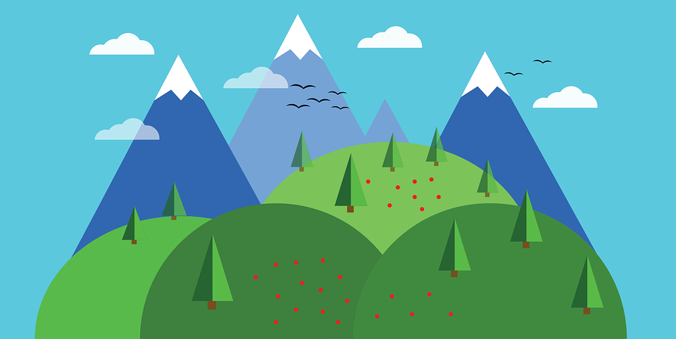
Setting

Your setting(s):

______________________________________________________________________________

Characters: Pick 2 main characters for your story.

Your main character(s): __________________________________________________________

______________________________________________________________________________________________________________________________________________________________________________________________________________________________________________________

Part 1 - Team planning

Write the Setup and Conflict parts of your story as a team to prepare for the next part when you will write individually.

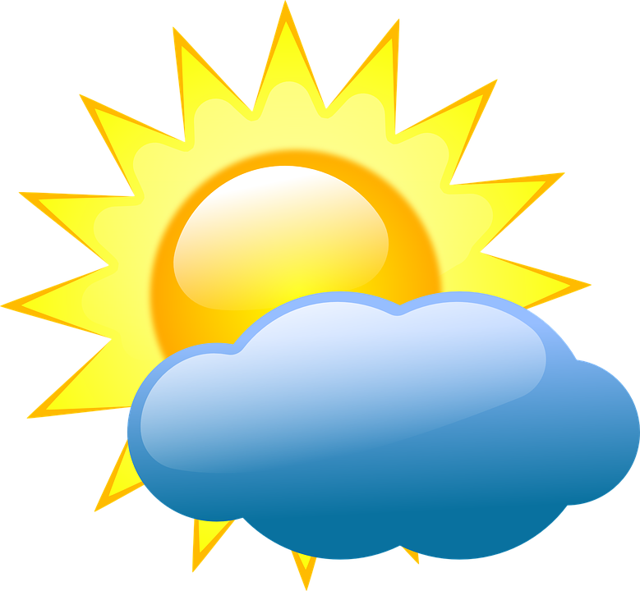Setup
In the setup, you could describe the time of the day, the year, the smell, the sounds, the objects in the setting and the name of the place. You could also give information about your main characters such as their names, what they wear, how they feel, their relationship, or actions that they do in the setup.

Once upon a time, ____________________________________________________________________________________________________________________________________________________________________________________________________________________________________________________________________________________________________________________________________________________________________________________________________________________________________________________________________________________________________________
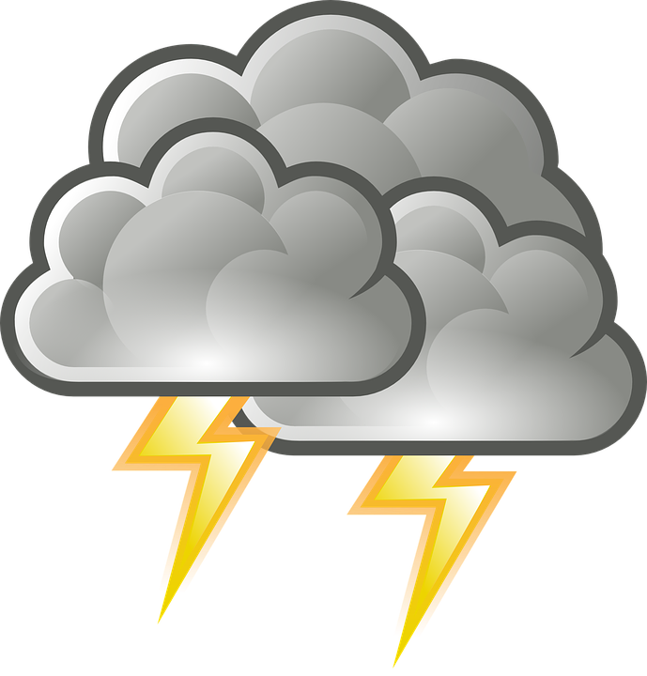Conflict
Keep the same setting as in the setup. Select the same main characters (you may add a new one that is related to the conflict).
The conflict is the major problem of the story. Describe the problem and give information on how the main characters react to this problem.

All of a sudden, ___________________________________________________________________________ ________________________________________________________________________________________________________________________________________________________________________________________________________________________________________________________________________________________________________________________________________
Note: Before continuing, as a team, decide who will be Student 1, Student 2, and Student 3 (if needed)

Part 2 - Individual writing

From now on, the rest of the story is written individually. Complete only your part of the text.

Student 1 only

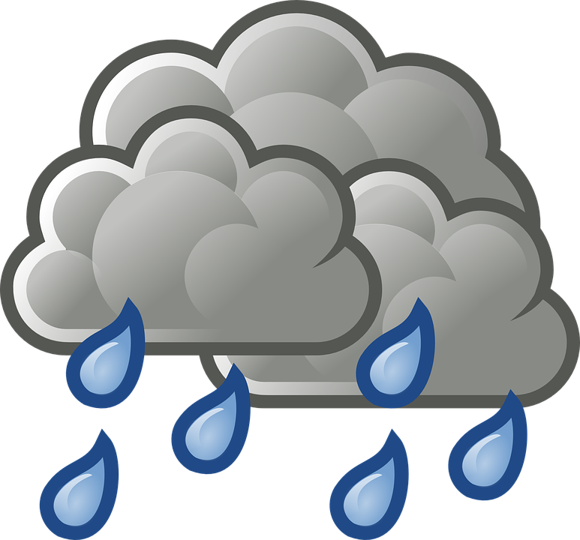Challenges: The main character(s) try to find a solution to the problem, but it doesn’t work. Look at the setting or at other characters to give you ideas.

Challenge 1: _________________________________________________________________________________ _____________________________________________________________________________________________________________________________________________________________________________________________________________________________________________________

Climax: One large event that changes the outcome of the entire story. The climax is when the main character(s) find(s) a real solution to the conflict.

_________________________________________________________________________________ ________________________________________________________________________________________________________________________________________________________________________________________________________________________________________________________________________________________________________________________________________

Student 2 only

Challenges: The main character(s) try to find a solution to the problem, but it doesn’t work. Look at the setting or at other characters to give you ideas.

Challenge 2: _________________________________________________________________________________ ________________________________________________________________________________________________________________________________________________________________________________________________________________________________________________________________________________________________________________________________________

Resolution: Describe the end of the story. The characters can be back to a neutral situation or another problem can appear. Do you want your story to end well or badly?

_________________________________________________________________________________ ________________________________________________________________________________________________________________________________________________________________________________________________________________________________________________________________________________________________________________________________________

Student 3 only
Challenges: The main character(s) try to find a solution to the problem, but it doesn’t work. Look at the setting or at other characters to give you ideas.

Challenge 3: _________________________________________________________________________________ ________________________________________________________________________________________________________________________________________________________________________________________________________________________________________________________________________________________________________________________________________

