LES - ENGLISH AS A SECOND LANGUAGE
Secondary
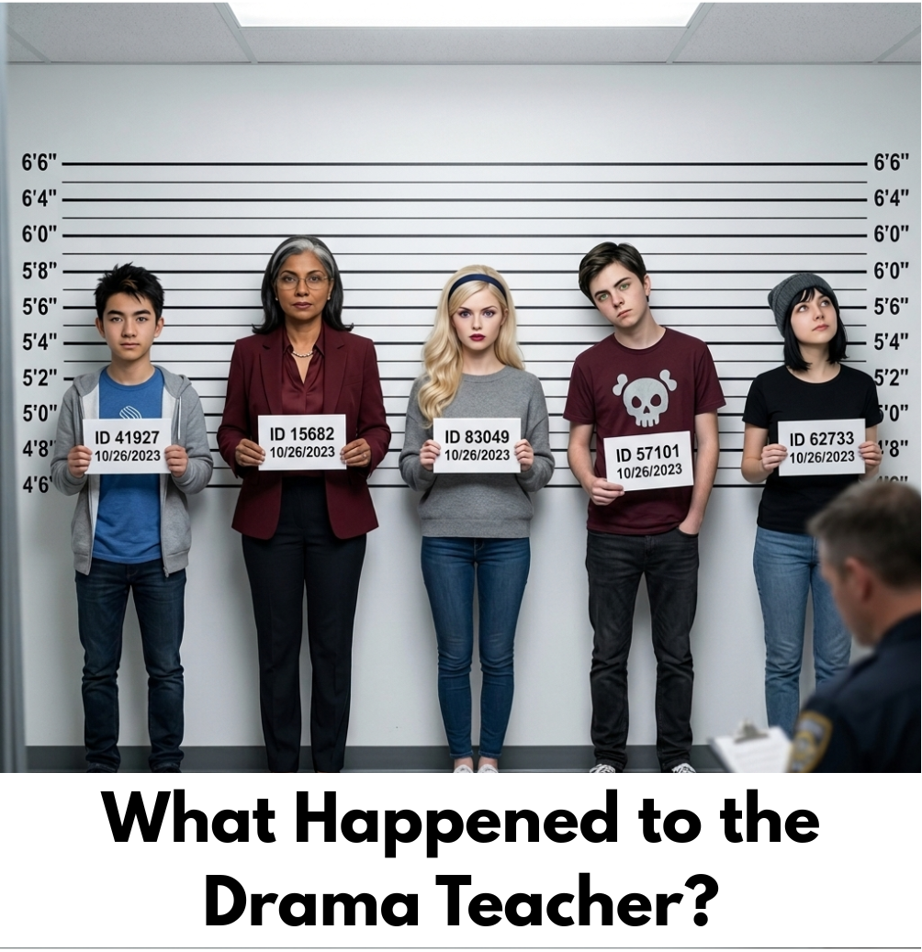
Student Booklet


Name:

The Scenario

What Happened to the Drama Teacher?

The drama teacher, Mr. Ramirez, was discovered unconscious by the school’s janitor backstage in the school auditorium. The janitor found him in this comatose state. No weapons were found on site.

The school’s surveillance camera showed that only 5 people were in the auditorium that night. They were practicing for the school play. All of them were present when the police arrived at 8:15 PM, 15 minutes after Mr. Ramirez was found unconscious, by the janitor.

Each of the individuals had a private conversation with Mr. Ramirez that fateful night. This fact is confirmed by the surveillance camera in the auditorium. Note that Mr. Ramirez had been off-camera since 7:30 PM. These 5 individuals are now identified as the main suspects.


In addition to these facts, we were informed that all 5 of the suspects had a particular relationship with the victim.

Mr Ramirez

Task 1 - You are now a suspect in this investigation

- Read the information on the suspect card you received.
- Consult the chart, Summary of Events.
- Identify the information that will be helpful to plan your story. Complete the grid with keywords.
TEXT INFORMATION | PERTINENT INFORMATION
MAIN CHARACTER
Identification of the suspect
Occupation of the suspect
SETTING
Arrival time at the auditorium (See Summary of Events)
Reason(s) for being at the auditorium
Connection to the victim
PROBLEM
Nature of the conversation with the victim (infer)
POSSIBLE SOLUTIONS
Alibi - Explanation of time off camera
Accusation of another suspect and reasons for this accusation

TASK 2 - The Hall Monitor


- Listen to the two versions of Leila’s digital story.
- Complete the grid with the specific characteristics of each of these digital stories.
Leila’s Suspect Card
Background
Time period: 5:50 PM—Filmed conversation: 6:00—6:10 PM
Location: Window of opportunity: 7:50—8:00 PM

Description
Personality: Quiet, shy and mysterious. She roams the halls every day and knows everything about everyone.
Context: Mr. Ramirez and Leila briefly dated a few years ago.

Motivation
Problem: Leila has been stealing from the teacher’s room, and Mr. Ramirez found out she was doing that. He warned her that she had to stop otherwise he would tell Ms. Dane about it.
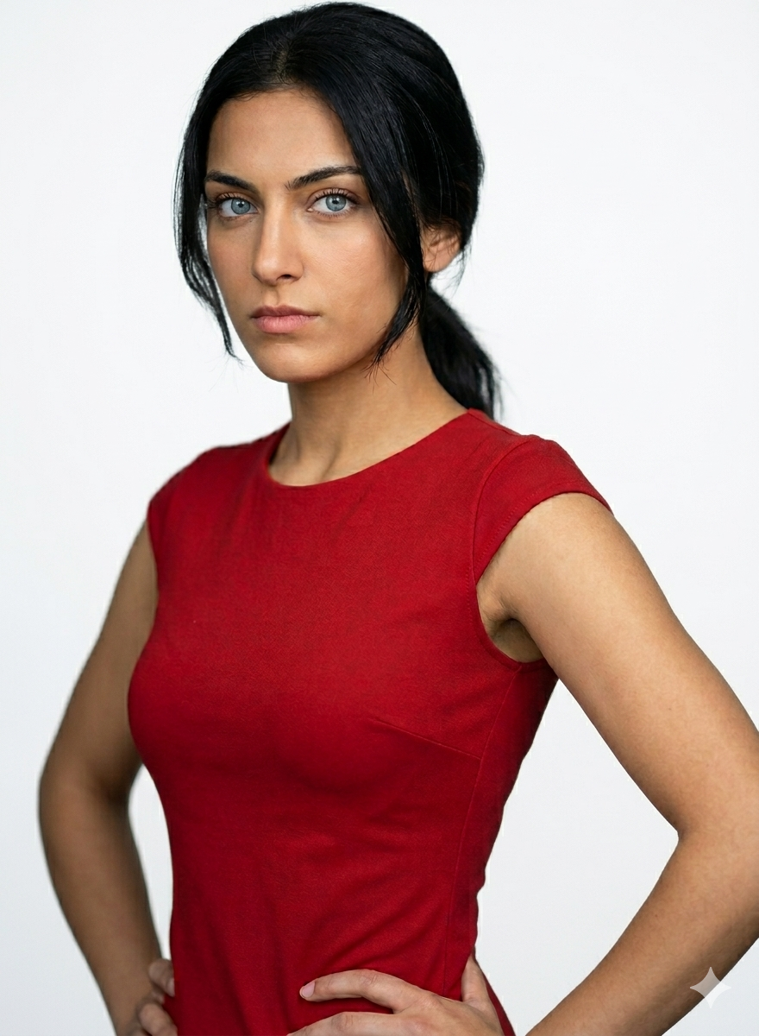
Outcome: Leila is already on probation and if Ramirez went to Dane, she might lose her job. She wants him not to reveal her secret.

Memorable Moments
Quote: “Ramirez wants to throw me under the bus, but he is no angel.”
Interesting Fact: Ms. Dane was never pleased with Mr. Ramirez’s work.

Personal Connection:
Impression: “Mr. Ramirez looked very nervous and distracted when he saw Ms. Dane enter the auditorium.”
Leila - Hall Monitor

Connection: Your turn to make links!
Characteristics of a Statement

Elements of a Digital Story | Explanation | Text 1 - Leila’s Statement 1 | Text 2 - Leila’s Statement 2
The Main Idea | How does the narrator get your attention at the start?  What is the main question we want answered by the end?
Emotional content  (Written Language) | How does the story make you feel? What words or events in the story created that feeling?Who is telling the story?  - A person inside the story (First person: uses "I" or "we")  - An outside narrator (Third person: uses "he", "she", or "they")
Dramatic Question | What is the main obstacle or problem the storyteller is trying to solve?  What was the unstated question that made you want to keep watching?
Voice  (Spoken Language) | How does the speaker sound? (e.g., excited, sad, serious, scared).  Do they pause at important moments?
Music | What kind of music or sound effects do you hear?  How do they help you understand the mood?
Visuals | Do the images help prove the story, or are they just for decoration?  Are the images clear and easy to understand?
Speed (Rythm) | Does the story move fast or slow?  Does the speed change during exciting parts?
Final lesson | Was the story believable?  What did you learn, or what was the main point the narrator wanted you to understand?

TASK 3a - Write Your Statement (double-spaced)

Write your statement here.

Task 3b – Peer Feedback and Revising Your Statement

- Read the text once to get a general idea. Do not write any notes on the text.
- Read the text a second time in order to provide feedback. You may use sticky notes.
- Answer the questions on the Peer Feedback Card.
- Pass your text to another team member.
- The new reader follows the same procedure and adds new comments only.
- Return the text to its original owner.
Revising Your Statement
- Decide which suggestions/comments you will accept and integrate into your text.
- Make the necessary changes (e.g. delete unnecessary parts, add missing details. When done, correct grammar, punctuation and spelling mistakes).

Reviewer’s name: ____________________________________________________________
Consider these questions about the text.  1. 🎯 The Target (Audience & Purpose)  Do you feel persuaded by this text?  - Yes, completely!  - A little bit.  - Not yet.  Does it sound right for police investigators? (Is it serious, clear, and professional?)  - Yes  - No  2. 🧩 Facts & Order  Are there enough facts, examples, and proof to make the police believe it?  - Yes  - It needs more proof.  Does the order of the ideas make sense, or is it confusing?  - It flows perfectly.  - It needs to be rearranged. | T - TELL the writer one fact or example they used that was very strong:  "I really liked when you mentioned..."  A - ASK a question about something that was missing, repetitive, or confusing:  "Why did you repeat..." or "Can you explain more about..."  G - GIVE one specific idea of something they should add or delete:  "You should add more facts about..." or "You can delete the part about..."

Reviewer’s name: ____________________________________________________________
Consider these questions about the text.  1. 🎯 The Target (Audience & Purpose)  Do you feel persuaded by this text?  - Yes, completely!  - A little bit.  - Not yet.  Does it sound right for police investigators? (Is it serious, clear, and professional?)  - Yes  - No  2. 🧩 Facts & Order  Are there enough facts, examples, and proof to make the police believe it?  - Yes  - It needs more proof.  Does the order of the ideas make sense, or is it confusing?  - It flows perfectly.  - It needs to be rearranged. | T - TELL the writer one fact or example they used that was very strong:  "I really liked when you mentioned..."  A - ASK a question about something that was missing, repetitive, or confusing:  "Why did you repeat..." or "Can you explain more about..."  G - GIVE one specific idea of something they should add or delete:  "You should add more facts about..." or "You can delete the part about..."
Make changes to your initial script after receiving feedback. Make sure you correct your text before creating your final draft.

Task 4– Plan your Storyboard

Frame 1
Description | Media and other details  (images, music, voice, rhythm, etc.)
Narration (text)
Frame 2
Description | Media and other details  (images, music, voice, rhythm, etc.)
Narration (text)

Frame 3
Description | Media and other details  (images, music, voice, rhythm, etc.)
Narration (text)
Frame 4
Description | Media and other details  (images, music, voice, rhythm, etc.)
Narration (text)

Frame 5
Description | Media and other details  (images, music, voice, rhythm, etc.)
Narration (text)
Frame 6
Description | Media and other details  (images, music, voice, rhythm, etc.)
Narration (text)

Frame 7
Description | Media and other details  (images, music, voice, rhythm, etc.)
Narration (text)
Frame 8
Description | Media and other details  (images, music, voice, rhythm, etc.)
Narration (text)

TASK 5- Record your Statement

Prepare the pictures you need for your digital story. You can find some on the Internet (be careful about copyrights - you can use pixabay.com), take your own photos, or use the pictures available in this learning situation.
Use one of these apps to create your statement. Don’t forget to take into account the elements of a digital story.



TASK 6- Who is the Accused Person?

Listen/view carefully to the different statements. Who do you think should be the accused person? Write down arguments to support your accusation.

