LES - ENGLISH AS A SECOND LANGUAGE
Secondary 2

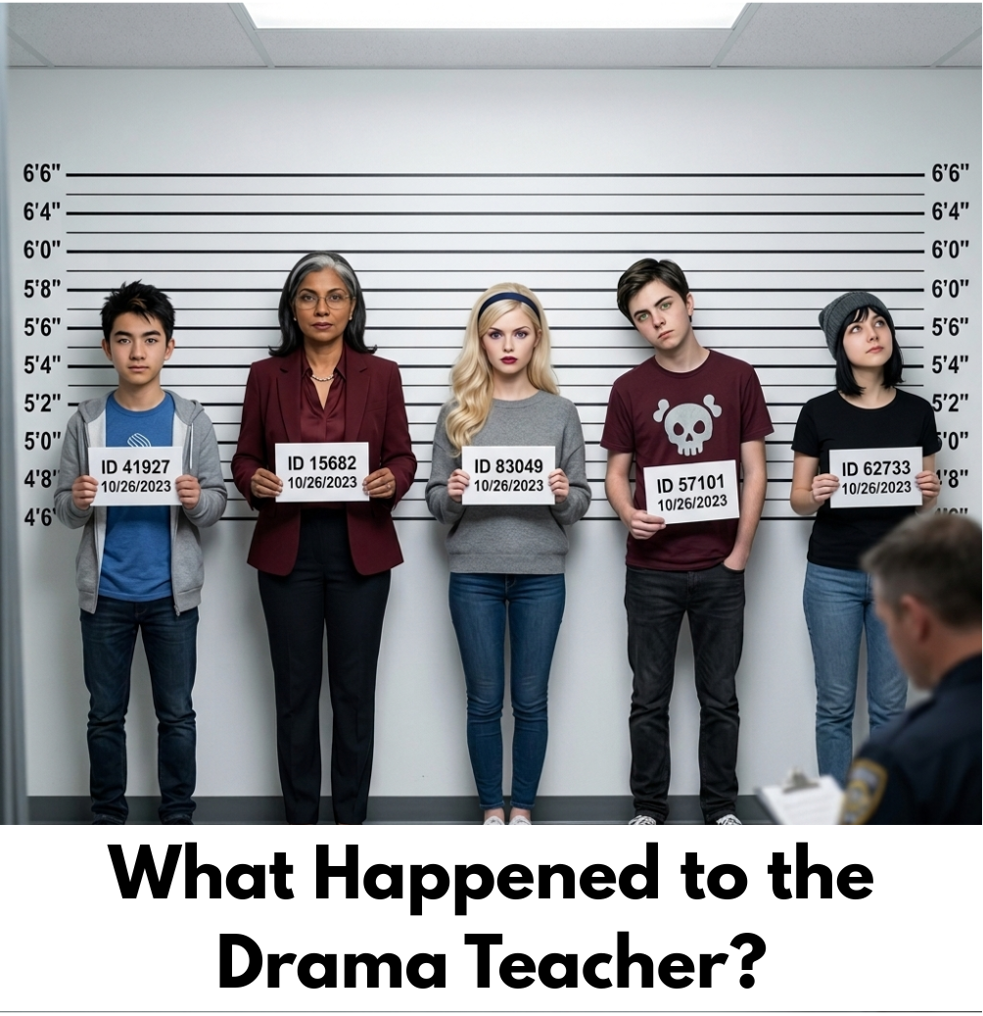

TEACHER GUIDE




Updated in 2026
Sandra Laine and Johanne Proulx, service national du RÉCIT, domaine des langues.
In collaboration with Dina Isber, Karine Vaillancourt, Christine Baida, Commission scolaire de Laval

Overview of the Learning Situation
Purpose
Students will write a formal statement and transform it into a digital media project.

Vocabulary related to the topic

deposition, crime scene, criminal, criminal record, cross-examination, innocent, guilty, witness, accusation, truth, cooperate, evidence, enigma, accomplice, solve, proof, facts, assault, alibi, nature of the injuries, wound, victim profile, victim, connection to the suspect, possible cause, natural cause, accident, suspect’s narrative, foul play

English as a second language
Competencies
Interacts orally in English | Participation in oral interaction  Content of the message  Articulation of the message (fluency and accuracy)
Reinvests understanding of texts | This LES can be adapted into a reinvestment task. To do this, ensure the response process is integrated for each text provided. Additionally, remove the 'Content of the message' (C3) criterion to avoid double-evaluating the same elements.
Writes and produces texts | Content of the message  Formulation of the text

Digital Tools
  Canva |   Google Vidz |   Clipchamp

The Scenario
The drama teacher, Mr. Ramirez, was discovered unconscious by the school’s janitor backstage in the school auditorium. The janitor found him in this comatose state. No weapons were found on site.

The school’s surveillance camera showed that only 5 people were in the auditorium that night. They were practising for the school play. All of them were present when the police arrived at 8:15 PM, 15 minutes after Mr. Ramirez was found unconscious, by the janitor.

Each of the individuals had a private conversation with Mr. Ramirez that fateful night. This fact is confirmed by the surveillance camera in the auditorium. Note that Mr. Ramirez was off-camera from 7:30 PM.

These 5 individuals are now identified as the main suspects.

In addition to these facts, we were informed that all 5 of the suspects had a particular relationship with the victim.

Overview of the LES - What Happened to the Drama Teacher?
Students will become potential suspects in this investigation. Students will personify the suspect and produce a testimony about what happened to the drama teacher.
In teams of 2-3, students will brainstorm their version of the events that took place by using information given to them on a suspect card.
They will:
- Write a text (testimony) about the event.
- Plan a digital story with a storyboard.
- Produce a digital story using a laptop or a tablet.
- Listen to the different testimonies.
- Decide who is guilty, and write down arguments to support their decision.

Classroom Activities
We created a new version of the characters using AI. Choose which version you wish to use.

Note to teachers: All documents are available via a "view-only" link. Please create a copy of the document if you need to make edits.
Period 1- You are a suspect |  | Material
1 | Before class, put the posters provided with this LES on the wall. | Old posters  New Posters  (PDF - Canva)
2 | Play the scenario video and present the intentions of this LES.  The video can be listened to again if needed. | Video  Old version - New Version
3 | Invite students to look at the different characters posted on the classroom wall.  Ask them to anticipate what happened to the drama teacher by participating in a survey using Kahoot on a device. You will need to Sign up or Log in to access the Kahoot.  Place students in teams of 3 or 4. Ask a student to access this address: kahoot.it using the browser (Safari or Chrome). Share the PIN number that appears when launching the survey.  Students enter the PIN number and a team name. They have 120 seconds to discuss and reach a consensus before answering each of the four questions. | Kahoot quiz  Old version - New Version  (Click on Start then Play, and the PIN will appear on  the screen). It needs to be projected on a screen for the students to see the  questions and possible answers.  Opportunity for C1
4 | Ensure students fully understand the scenario. | C2 opportunity - This is the first text. You can add questions to go through the response process if you want to transform this into a reinvestment task.
5 | Introduce the Student Booklet. | Student Booklet  (choose the version you need on the site)
6 | Task 1 SB - Form teams of 2-3 students. Give each team a suspect card. Inform students not to share the information that is on their suspect card. | Suspect Cards  Old version  (Slides - PowerPoint - Canva)  New version in colour  (Slides - PowerPoint - Canva)  New version B&W  (Slides - PowerPoint - Canva)
7 | Task 1 SB - Individually students will identify the information that will be helpful to plan their text on the card they received. Ask them to look at the Summary of Events in their booklet (SB, p.4). and fill out the grid with keywords. Support students during this task by circulating in the classroom.  *Note that the problem should not be a copy/paste of what is on the character card. Students need to divert the police’s attention to another suspect. | C2 Opportunity - This is the second text. You can add questions to go through the response process if you want to transform this into a reinvestment task.

Period 2 - Analyse a testimony |  | Material
1 | Task 1 SB - Ask students to join their group and share  the information found during task 1. | Student Booklet
2 | Explain the elements of a digital story (SB, p.5). Use the questions to analyze the two versions of Leila’s testimony.  The elements of a digital story haven been adapted to ESL students. Click here to learn more. | Elements of a digital story
3 | Task 2 SB - Present the two versions of Leila’s testimony.  Ask students to write down the  characteristics of that particular digital story.  Invite students to complete the chart in their booklet (SB, p.6). | Testimony videos:  - Leila 1  - Leila 2  Speakers  Projector
4 | Recap on findings. | C2 Opportunity - This is the second text. You can add questions to go through the response process if you want to transform this into a reinvestment task.

Period 3 - Write a Testimony |  | Material
1 | Go back to the scenario and explain that they will use the information from the suspect card and the summary of events. | Student Booklet
2 | Task 3a SB - Invite students to write a statement  individually in their booklet by using the information from the texts and their own.  Use the following resources: SB, p. 2, 3, 4 and the  suspect card. (Redistribute the suspect card to each  student.) Remember that the problem should not be acopy/paste of what is on the character card. Studentsneed to divert the police’s attention to anotherSuspect.  Present the text features of the task (rubric) before they write. See the elements suggested on p.8. | C3 - Writes texts  C2 - If you went through the response process for each of the texts, it is possible to evaluate both C2 and C3. Don’t forget to remove 'Content of the message'  C3 Rubric
3 | Task 3- Group students in their initial team and invite them to exchange their text in order to provide and receive feedback. They will read two texts (teams of 3).  Students complete the feedback cards in their SB p. 7 and 8. You can choose other elements to provide feedback on depending on your intentions.  Once the peer feedback session is over. Ask students to review their texts according to the comments they receive. Once revised, they have to edit (correct mistakes, grammar, etc.) before the next step. | Student Booklet  Dictionary  Thesaurus

Period 4 - Plan a Storyboard |  | Material
1 | Task 4 SB - Once the text (statement) is finished,  explain to students that they will need to plan a  storyboard of their digital story before recording it.  *The teacher decides if the students produce their  individual digital story or a collective one. If you  decide on a collective one, students decide on the text that will be used for the storyboard. | Student Booklet
2 | You can present the selected app to students before  they plan their storyboard. They will know what is  available for their production: backgrounds, music,  templates, etc. | Canva  ClipChamp  Google Vidz

Period 5 - Record a Testimony |  | Material
1 | Ask students to prepare the pictures needed for their  digital story. They can look for some on the Internet  (be careful about copyrights - Pixabay is a good  resource for them), take their own photos or use the  pictures available to them in this learning situation.  *If you don’t have a lot of time in class, students can  search for, or take pictures at home. | Student Booklet  Pictures of the suspects  Old version - New Version
2 | Task 5: Invite students to use one of the proposed  apps to create their testimony. Remind them to take  into account the elements of a digital story.  Ask students to send the productions to you using one of these solutions: TEAMS, Classroom, Email, AirDrop, Shared folder in your Drive, etc. | Devices  Headsets or Microphones

Period 6 - Who Will Be Accused? |  | Material
1 | Task 6 SB - Select five statements, one for each suspect. You can also decide to present all of them. Invite students to carefully listen to each statement. Ask students to write down who they think is the accused person, and the arguments to support their decision.  Group students according to the nature of their  accusation. Invite them to share their arguments. *C1  can be evaluated in this task.  One student can represent the group. He will have the mandate to explain who is guilty and why. | Speakers  Projector  Student booklet  C1 Evaluation  Rubric
2 | Final Task: Students vote for who they think is the  accused person. The teacher can determine who is the accused person according to students' productions or choose one of the outcomes available here. | Rubric C1

C1 Rubric
Select the elements you will observe in each of the C1 task you wish to evaluate. Inform students beforehand.
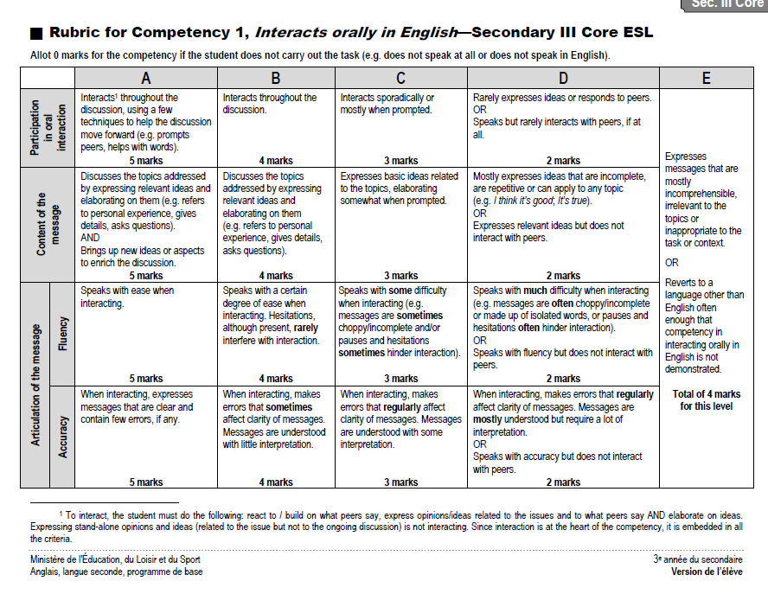
C3 Rubric
Use the following elements to add to your C3 rubric

Content
- Pertience of the message in light of:
  - Purpose: To persuade
  - Audience: Police investigators
Text Components
- Introduction that hooks the reader
- Dramatic question: A clear, central mystery or problem stated in the introduction that keeps the person reading.
- Development paragraphs using facts/evidence
- Conclusion with a final main point
Formulation of the Message
- Accuracy of targeted language repertoire: Text written in the first person
- Clarity of message
- Use of text components/text features appropriate to text form

When students get to the media production of their message, they might need to be reminded of these elements as seen when they deconstructed Leila’s testimony.
Voice (Spoken Language)
- How does the speaker sound? (e.g., excited, sad, serious, scared).
- Do they pause at important moments?
Music
- What kind of music or sound effects do you hear?
- How do they help you understand the mood?
Visuals
- Do the images help prove the story, or are they just for decoration?
- Are the images clear and easy to understand?
Speed (Rythm)
- Does the story move fast or slow?
- Does the speed change during exciting parts?

